Homework 5.2: Adding & Subtracting Rationals Name: ______________________
Math 3

Directions: Simplify each sum or difference. State any restrictions on the variables.

- 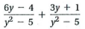
- 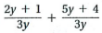

- 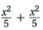

- 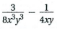

- 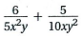
- 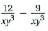

Directions: Simplify each sum or difference. State any restrictions on the variables.

- 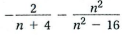
- 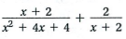

- 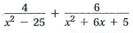
- 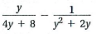

Directions: Simplify the complex fractions. State any restrictions on the variables.

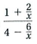

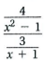
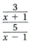

- Angela simplified the following rational expressions. She correctly simplified one out of the three problems. Determine which one she answered correctly. Also, identify and correct where she went wrong in the other two problems.

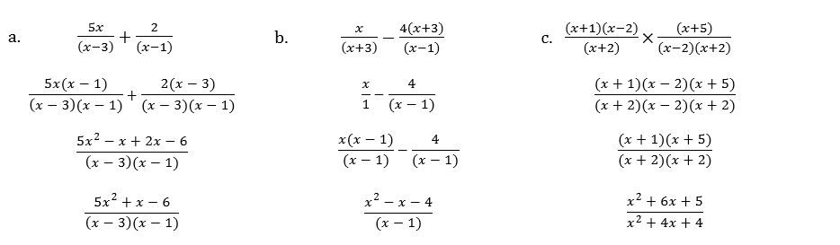

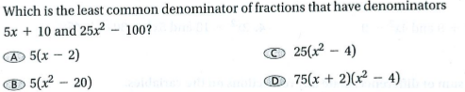

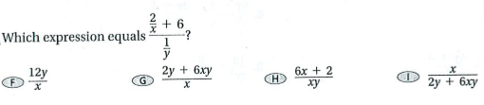

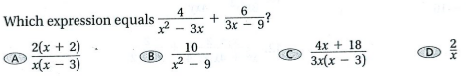

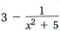
- Subtract . Write your answer in simplest form. State any restrictions on the variable.

